**Greedy or Not**

It was a more straightforward challenge if time complexity was not considered. The algorithm was to find the maximum number from both ends and add it to p1 or p2, depending on the turn. The selected element was subsequently deleted from the array, and the length was checked not to be zero. Test cases were checked, and the correct output was obtained. The code is posted on my Git Hub repository.

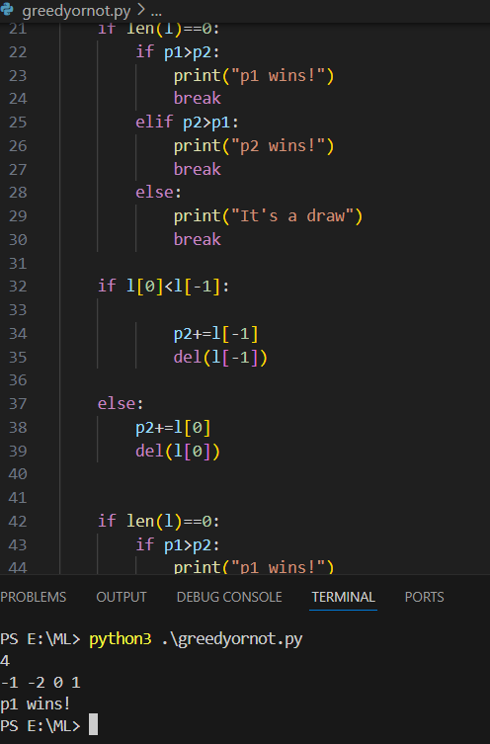

Coding has been done in python (optional task).